Basic Design Principles

1. High Cohesion and Low Coupling

2. LoD
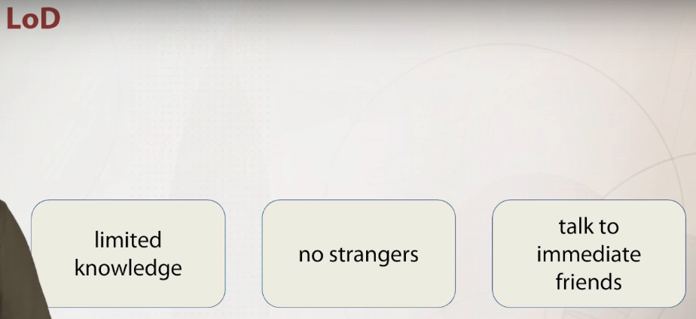
3. SOLID
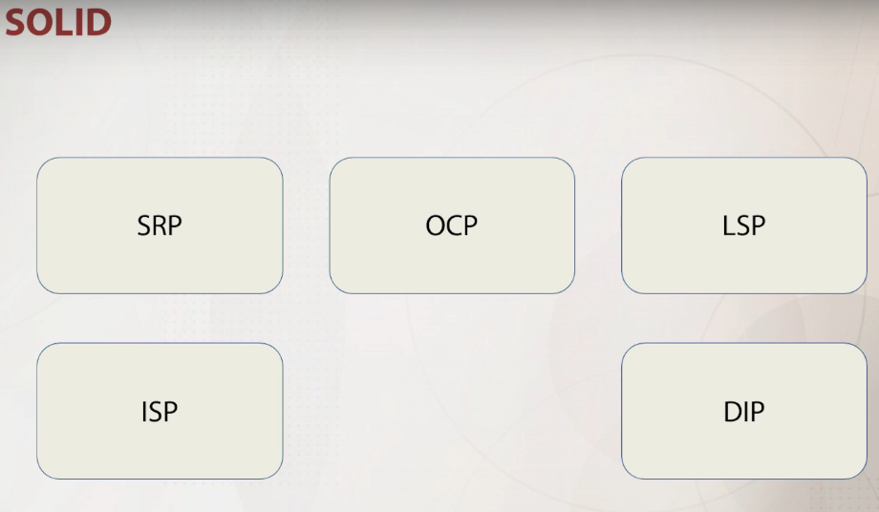
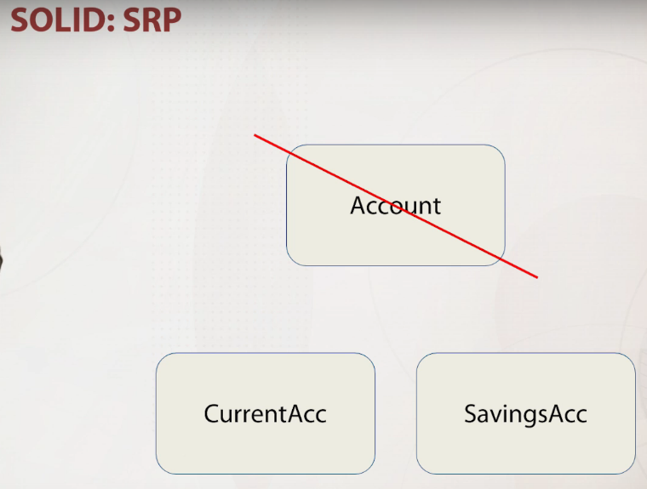

This principle states that there should never be more than one reason for a class to change.
Design class in such way that each class should have a single purpose.

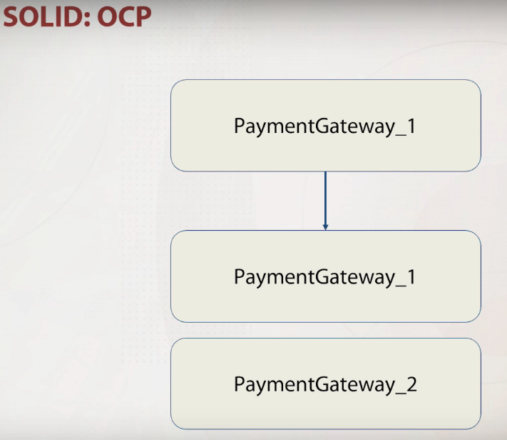
This principle states that software entities, classes, modules, functions, etc, should be open for an extension, but closed for modification.
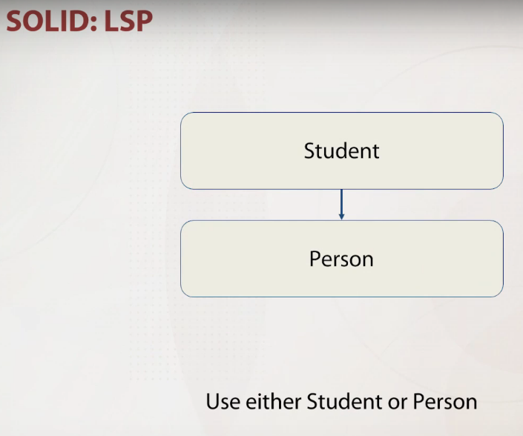
This principle states that function that use pointers or reference to base classes must be able to use objects of derived classes without knowing it.

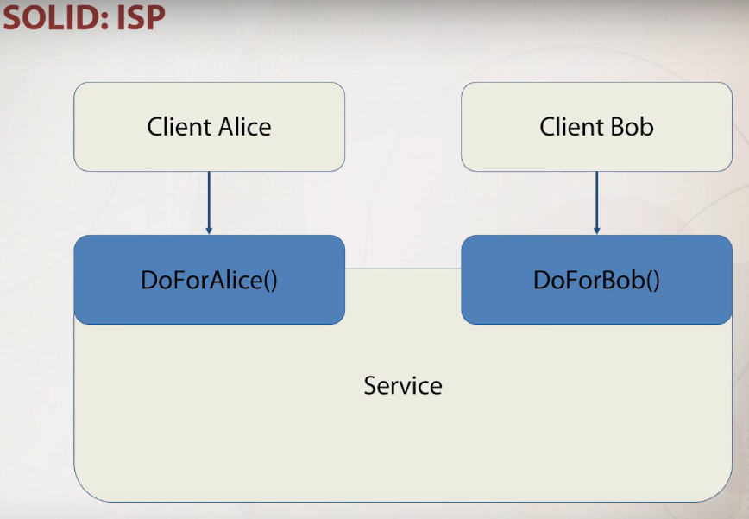
This principle states that client shouldn't be forced to depend upon interface that they don't use.

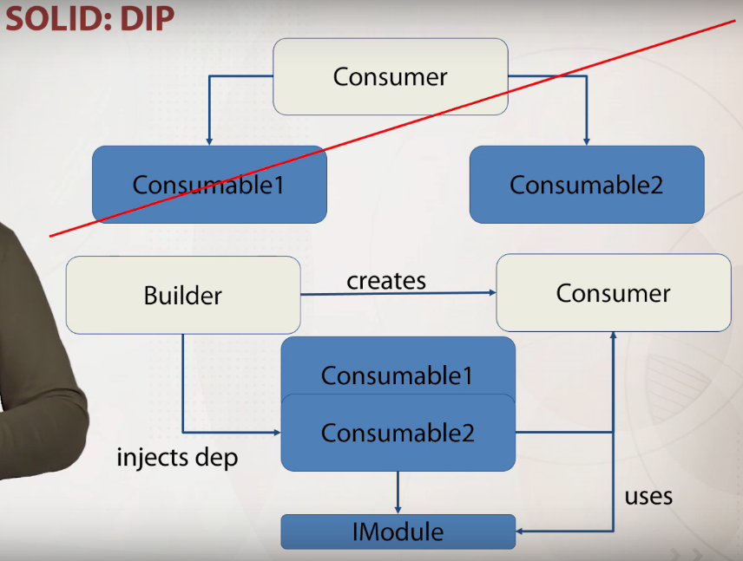

This principle states that higt-level modules should not depend upon low-level modules. Both should never depend upon abstractions, and the last thing that abstraction should not depend upon details.

4. DRY
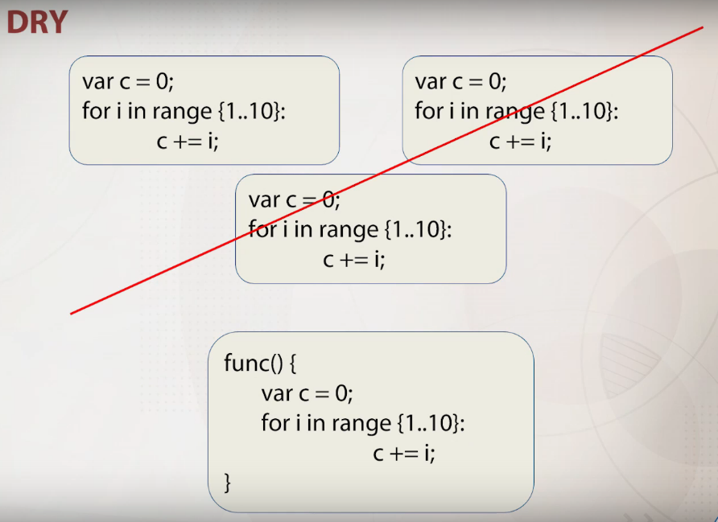
5. KISS
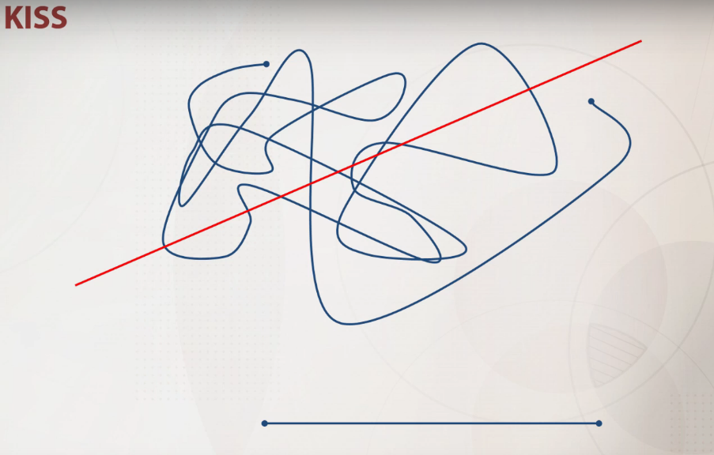
This principle states that you should try to keep each small piece of software as simple and unnecessary complexity should be avoided.

6. YAGNI

This principle states that you should always implement things that you actually need them and never impement things before you need them.

Basic Software Architecture Types

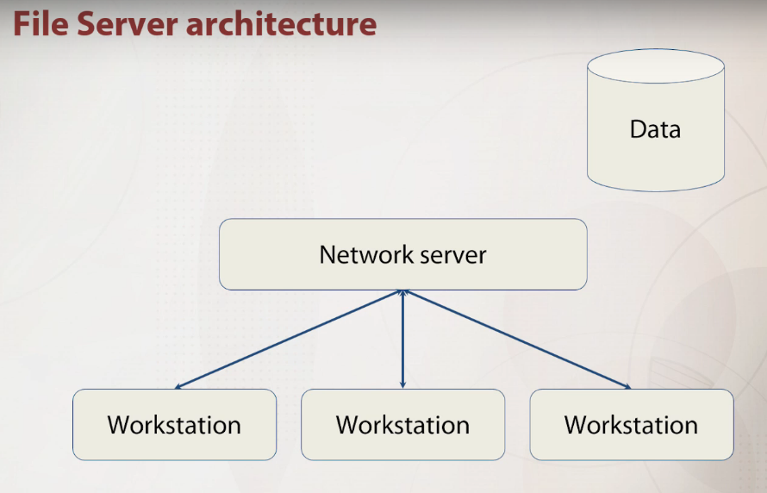
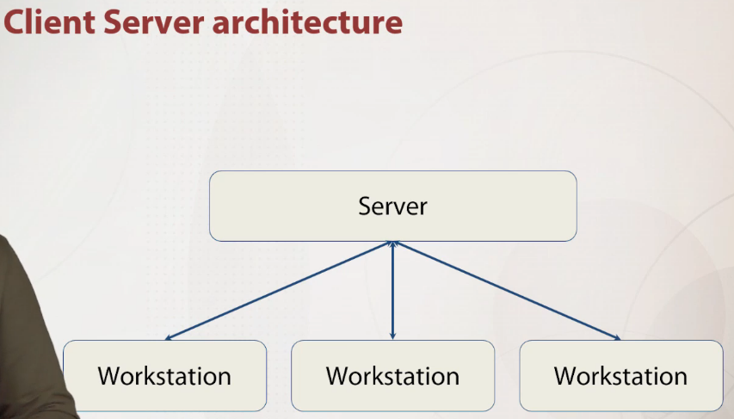

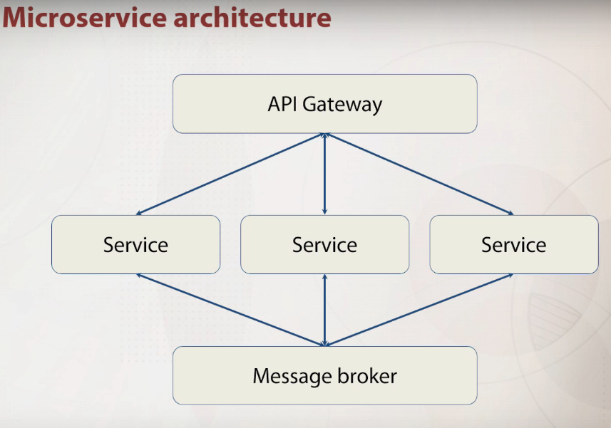
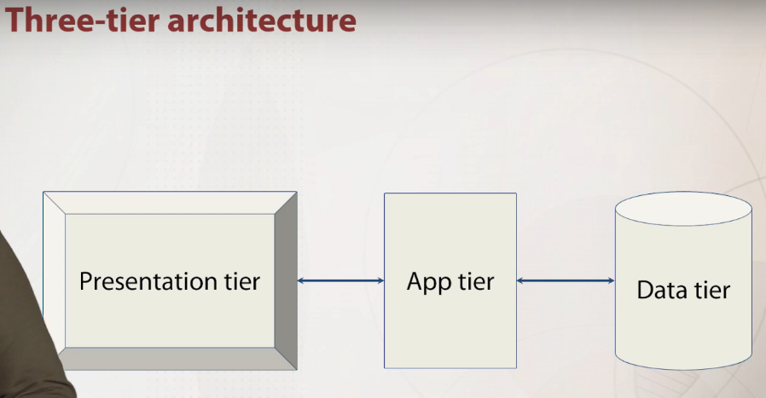
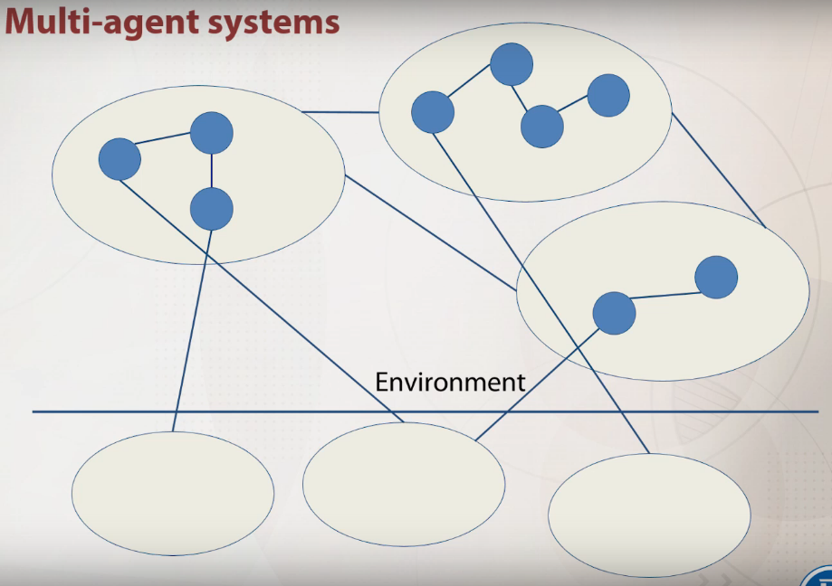

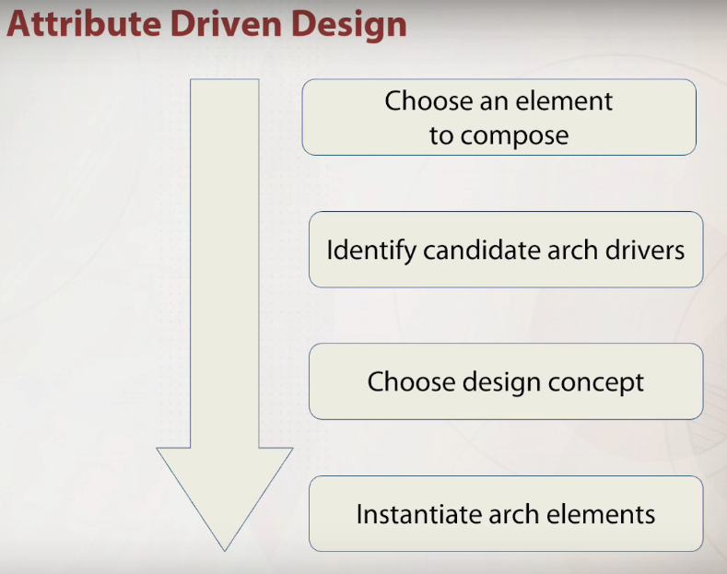
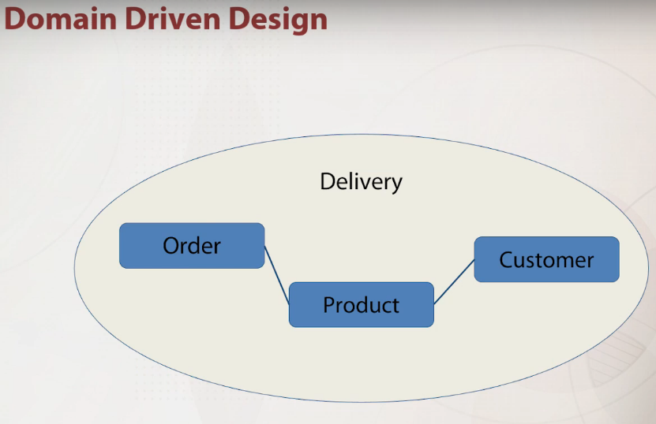

What is the components role in software architecture?
Components are made up of (compiled from) the programs in the various implementation units.

What is the allocations role in software architecture?
Allocations are the mapping from software structures to the system’s organizational, developmental, installation, and execution environments.

Which statement correctly describes the Single Responsibility Principle?
This principle states that there should never be more than one reason for a class to change.

Which statement correctly describes the KISS principle?
This principle states that it is necessary to keep each small piece of software simple and unnecessary complexity should be avoided.

Which statement correctly describes the DRY principle?
This principle states that each small pieces of knowledge (code) may only occur exactly once in the entire system.

Which statement correctly describes the tree-tier architecture?
This architecture introduces three layers: presentation, application and data.

Which statement correctly describes the role of an application tier in a three-tier model?
Application tier controls an application’s functionality by performing detailed processing.

Which statement correctly describes the multi-agent systems?
Agent environments can be organized according to properties such as accessibility and determinism.

Which statement correctly describes the Domain Driven Design?
This is the concept that the structure and language of software code should match the business domain.

